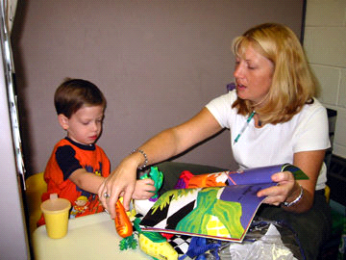
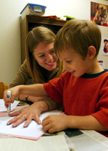
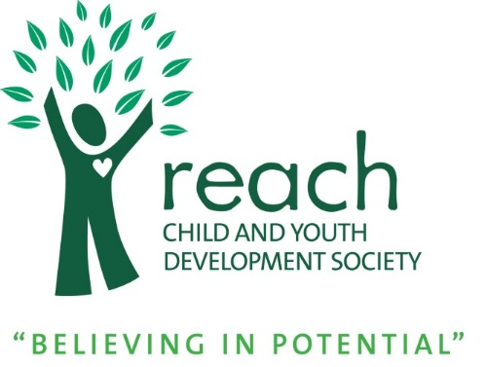
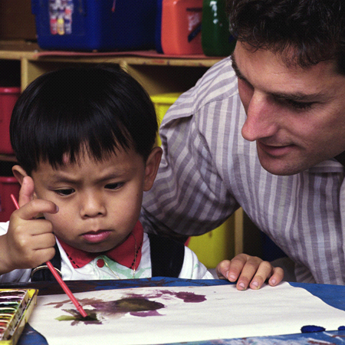
REACH Autism Program for Children under 6
Family Handbook
5050 47th Avenue,
Delta, BC V4K 0C8
604.946.6622
www.reachchild.org

An Interdisciplinary Intervention Program
for Children under the age of 6 with Autism Spectrum Disorders

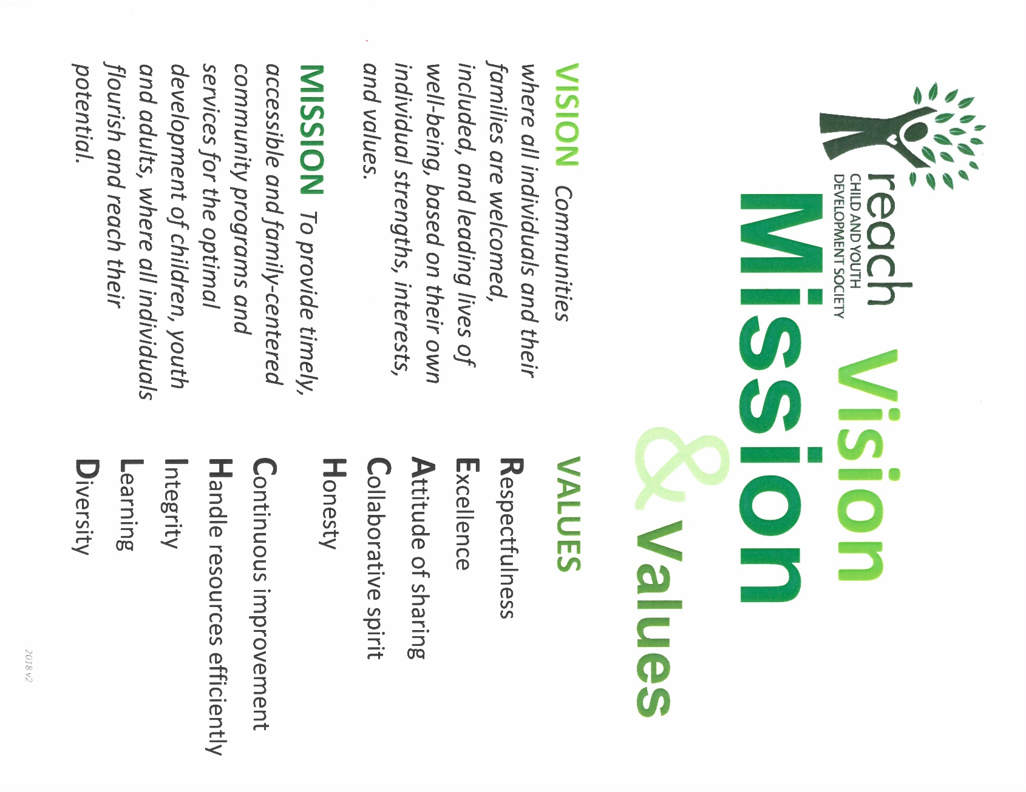
VISION Communities where all individuals and their families are welcomed, included, and leading lives of well-being, based on their own individual strengths, interests, and values.

MISSION To provide timely, accessible and person- and family-centered community programs and services for the optimal development of children, youth and adults, where all individuals flourish and reach their potential

Reach Child and Youth Development Society

Vision, Mission, Principles and Values

Vision
Communities where all individuals and their families are welcomed, included, and leading lives of well-being, based on their own individual strengths, interests, and values.

Mission
To provide timely, accessible person- and family-centered community programs and services for the optimal development of children, youth and adults, where all individuals flourish and reach their potential.

Guiding Principles
- Appreciating childhood as a unique and valuable stage of the human life cycle and basing our work with children and youth on the knowledge of child development.
- Appreciating and supporting the bond between the child, youth, adult and family.
- Facilitating a person-centred approach as children grow based on the belief that all people have the right to control their own lives through personal choices about relationships, jobs, living arrangements, spirituality, travelling, and recreational activities, and that all people have the right to give back to their communities through volunteering and helping others. We also believe that these rights can be reinforced and protected by making sure that people are connected to and supported by friends, family, staff, and the community.
- Recognizing that children, youth and adults are best understood and supported in the context of family, culture, community, and society.
- Respecting the dignity, worth and uniqueness of each individual (child, youth, adult, family member, and colleague).
- Helping children, youth and adults achieve their full potential in the context of relationships that are based on trust, respect, and positive regard.
- That individuals are best nurtured by a family that knows, loves and honors them for who they are.
- That all individuals have the right to be part of an inclusive environment that meets the needs of individuals with and without disabilities.
- That relationships and friendships are essential to enrich our lives.
- That all individuals are entitled to the services and supports required to ensure their full participation in our society.
- That the involvement of families and support networks contributes to everyone's safety and well- being.
- That services and supports must be delivered in a way that respects an individual's diverse history, culture, race, religion, gender and sexual orientation.
- That inclusive communities enrich the lives of all citizens.

Values
Continuous improvement
Respectfulness
Excellence
Attitude of sharing
Collaborative spirit
Honesty

Handle resources efficiently
Integrity
Learning
Diversity

Table of Contents
Page

REACH’S HISTORY 1
REACH’S VISION AND MISSION 1
REACH IS A CARF ACCREDITED AGENCY 1
Services Provided by REACH Include: 1
THE REACH Autism PROGRAM 2
THE REACH Autism program TEAM 2
Behaviour Consultants 2
Associate Behaviour Consultants 3
Speech-Language Pathologists 3
Occupational Therapists 4
Behaviour Interventionists 4
REACH Autism PROGRAM OPTIONS 5
Play and Learn Peer Connections Program 5
Play and Learn Family Connections Program 6
BEHAVIOUR PLAN OF INTERVENTION 9
REFERRAL, ELIGIBILITY AND WAITLIST PROCEDURES 10
REACH Autism Program POLICIES AND PROCEDURES 10
Hours of Operation and Statutory Holidays 10
Billing Procedures 10
Intervention Area 10
Program Binders and Data 10
Program Materials 11
Scheduling Sessions for Home Sessions 11
Cancelling an Intervention Session 11
Sick Policy (How do I know that my child is too sick for intervention?) 11
Grievance Policy 11
Release of Information 12
Videotaping 12
Health and Safety 12
Smoking 12
Transportation 12
Personal and Professional Boundaries 12
Gifts 13

REACH’S HISTORY
REACH is a nonprofit organization that has been providing services to children and their families since 1959. REACH currently serves the regions of Delta, Surrey and Langley. We offer a variety of services designed to meet the needs of children to ensure their optimum development. Over 1000 children and their families benefit from our services on an annually.

REACH’S VISION AND MISSION
MISSION: To provide timely, accessible and family-centered community programs and services for the optimal development of children, youth and adults, where all individuals flourish and reach their potential.
VISION: Communities where all individuals and their families are welcomed, included, and lead lives of well-being, based on their own individual strengths, interests, and values.

REACH IS A CARF ACCREDITED AGENCY
REACH is accredited by the Commission on Accreditation of Rehabilitation Facilities (CARF), an international organization that sets standards of quality of service. This means that we have been recognized as providing responsive, high quality programs and services that meet the needs of the children and families in our community.

Services Provided by REACH Include:
- Aboriginal Supported Child Development
- Choices Program
- Delta Connex
- Infant Development Program
- Therapies Program (Occupational Therapy, Speech-Language Pathology, Physiotherapy)
- REACH Autism Program
- REACH Counselling Services
- REACH Developmental Preschools
- Positive Behaviour Support Program
- Positive Connections Program
- Respite Program
- Supported Child Development

THE REACH AUTISM PROGRAM
The Reach Autism Program is a family-centred program that provides individualized services customized to the needs of each child and family. Families are the key decision makers in establishing priorities for intervention, and the Reach team provides education and training to assist families in creating a supportive environment for their child to learn and develop.
The Reach Autism Program is an interdisciplinary, highly structured autism intervention program. Our intervention focuses on six child development areas: play skills, communication skills, social skills, fine motor skills, self-help skills, and academic skills. We use a systematic protocol of instruction with naturally motivating activities whereby children acquire new skills in natural contexts. Positive feedback is given to children regularly to reassure their efforts. Our approach also incorporates the child’s interests and choices; we use a systematic prompting technique to ensure children learn functional skills with confidence.

THE REACH AUTISM PROGRAM TEAM
The Reach Autism Program includes behaviour consultants (BCs), speech-language pathologists (SLPs), occupational therapists (OTs), associate behaviour consultants (ABCs), and behaviour interventionists (BIs). The Reach Autism Program’s BCs, ABCs, SLPs, and OTs all have extensive experience and expertise to support families.
The most important team member is the family. The family sets priorities for intervention and plays the most significant role in the direction of treatment for their child. Below are the Reach Autism Program team’s roles and responsibilities:

Behaviour Consultants
Behaviour consultants (BCs) develop and monitor the behaviour plan of intervention (BPI) by coordinating the assessment, setting goals in collaboration with the family and the Reach Autism Program team, and providing appropriate programming to address these goals. BCs also coordinate the development of positive behaviour support plans, which focus on reducing the occurrence of challenging behaviours by restructuring the environment and teaching alternative, appropriate behaviours.
The child’s BC, in collaboration with the child’s OT and SLP:
- Assesses the child’s communication, cognitive, play, social interaction, motor and self-help skills;
- Develops and writes the child’s behaviour plan of intervention (BPI);
- Provides the instructional programs that address the goals in the BPI.
- Observes the child during intervention sessions either in person or via video recording;
- Reviews program data collected by the behaviour interventionist, monitors the child’s progress, and adjusts teaching strategies as needed;
- Monitors and updates the behaviour plan of intervention on a regular basis;
- Consults with the family and team regarding the child’s development, teaching strategies, generalizing newly developed skills, and decreasing challenging behaviours.
Behaviour consultants working in our program have a master’s degree and a minimum of 14 years of experience developing and directing programming for children with ASD in an intensive behaviour intervention program. All consultants are listed on the Registry of Autism Service Providers (RASP).

Associate Behaviour Consultants
Associate behaviour consultants (ABCs) work under the direct supervision of behaviour consultants and provide ongoing training to behaviour interventionists. ABCs communicate with the other Reach Autism Program team members on an ongoing basis and supervise behaviour interventionists.
The child’s associate behaviour consultant:
- Observes intervention sessions and provides training and direction to the behaviour interventionist regarding session structure and organization, the implementation of instructional programs, accurate data collection, and managing challenging behaviours;
- Consults with the child’s team regarding the implementation of programs;
- Video records intervention sessions; and
- Assists in teaching the family strategies to help generalize newly developed skills into everyday activities.
Associate behaviour consultants working in our program have a bachelor’s degree and at least 6 years of experience working in the Reach Autism Program.

Speech-Language Pathologists
Speech-language pathologist (SLPs) collaborate in assessing, setting goals and providing programming to address the development of the child’s communication skills. SLPs also provide consultation and training to help parents implement strategies that teach and develop their communication skills in everyday activities. The Reach Autism Program’s SLPs do not provide direct therapy to the child. Instead, they provide the instructional programs, training and supervision to the BIs who practice the communication activities with the child each session.
The child’s speech-language pathologist performs the following tasks:
- Assesses the child’s communication skills and assists in the development of the behaviour plan of intervention;
- Provides the instructional programs that address the communication goals in the BPI;
- Observes the child during intervention sessions and provides direction to the BI in implementing communication programs;
- Monitors and updates communication programs;
- Consults with the family and team as needed; and
- Attends team meetings
Speech-language pathologists working in our program have master’s degrees and are members of the College of Speech and Hearing Health Professionals of BC. All speech-language pathologists have a minimum of 13 years of experience working with children with ASD in an intensive behaviour intervention program. All Reach Autism Program SLPs are listed on the RASP.

Occupational Therapists
Occupational therapists (OTs) collaborate in assessing, setting goals and providing programming to address the development of the child’s fine motor and self-help skills. OTs also provide consultation and training to help parents implement strategies to help generalize newly developed skills. The Reach Autism Program’s OTs do not provide direct therapy to the child. Instead, they provide the instructional programs, training and supervision to the BIs who practice the fine motor and self-help activities with the child each session.
The occupational therapist performs the following tasks:
- Assesses the child’s fine motor and self-help skills and assists in the development of the behaviour plan of intervention;
- Provides the instructional programs that address the child’s fine motor and self-help goals in the BPI;
- Observes the child during intervention sessions and provides direction to the BI in implementing fine motor and self-help programs;
- Monitors and updates fine motor and self-help programs;
- Consults with the family and team as needed; and
- Attends team meetings
Occupational therapists working in our program have a master’s degree and are members of the College of Occupational Therapists of BC. All occupational therapists have a minimum of 12 years of experience working with children with ASD in an intensive behaviour intervention program. All Reach Autism Program occupational therapists are listed on the RASP.
Reach Autism Program’s SLPs and OTs provide consultation services and do not provide direct therapy.

Behaviour Interventionists
We provide trained BIs to implement children program plan. Behaviour interventionists (BIs) are responsible for providing one-to-one intervention, small group teaching and facilitation, recording data, creating program materials, and rotating toys.
Behaviour interventionists perform the following tasks:
- Implement instructional programs provided by the child’s behaviour consultant, speech-language pathologist and occupational therapist;
- Take data on the child’s performance;
- Prepare materials and rotate toys; and
- Attend team meetings
Behaviour interventionists have a degree, diploma, or certificate in early childhood education or a related field, and/or the equivalent experience. Behaviour interventionists also have first aid training. All Reach Autism Program behaviour interventionists are employees of REACH Child & Youth Development Society and have WorkSafe BC coverage.

THE REACH AUTISM PROGRAM OPTIONS

PLAY AND LEARN PEER CONNECTIONS
Available at Reach Centres only

Play and Learn Peer Connections is centre-based and focuses on teaching children how to succeed in preschool and school. Children have individualized goals, and participate in play-based, highly structured 1-1 and small group activities. Children attend three days a week for a total of 27-30 hours per month. Each child’s group readiness will be assessed prior to starting the program.

Group Time
Children participate in small groups and intervention goals focus on preparing children for other group environments such as preschool, and school settings. Group activities involve peer interactions and are designed to help children practice the communication and play skills they learn in 1-1 sessions. Children will also learn social skills, emotional regulation, and executive functioning skills as they participate in activities with peers.

1-1 Time
All children also have a 1-1 teaching time with a BI, outside the group time. Goals may include developing children’s language and communication, play, cognitive, fine motor, and self-help skills.

Your Team
Your child’s team will consist of a behaviour consultant (BC), associate behaviour consultant (ABC), speech-language pathologist (SLP), occupational therapist (OT), and behaviour interventionists (BIs). Your family, BC, ABC, SLP, and OT will work together to develop your child’s individualized program plan.

Staffing
Group instruction will have a 2:3 ratio of behaviour interventionists to children. Your associate behaviour consultant will also be on-site every day. Your child’s BC, SLP, and OT will observe your child 1-2 times per month and update teaching strategies, programming, and goals. If your child is absent during your BC/SLP/OT’s visit, they will watch a video recording of your child’s session.

Closure
Play and Learn Peer Connections is a year-round program, with two-week closures during spring break, at the end of August, and during winter break.
Locations:

Ladner Centre | Fleetwood Centre | North Delta House
5050 47 Avenue, Delta | #205 – 16140 84 Avenue, Surrey | 10921 82nd Avenue, Delta
Mon, Tue, Wed | Mon, Wed, Fri | Tue, Wed, Thu
12:15-2:30 pm or  3:00-5:15 pm | 9:15 -11:30 am, or  12:15-2:30 pm or  3:00-5:15 pm | 9:15 -11:30 am, or  12:15-2:30 pm or  3:00-5:15 pm

Fees for Play and Learn Peer Connections are charged monthly:

Behaviour Consultant – 1.5 hours | $262.50
Associate Behaviour Consultant – 3 hours | $270.00
Speech-Language Pathologist – 1.5 hours | $262.50
Occupational Therapist – 1.5 hours | $262.50
Behaviour Interventionists – 13 days | $1300.00
Approximate monthly fee | $2357.50

Cancellation policy – If families cancel a session, the regular fees still apply. During your child’s absence, your team (BI, ABC, SLP, OT or BC) will make program materials and update your child’s programming.

PLAY AND LEARN FAMILY CONNECTIONS
Available at Reach Centres or in Homes

Play and Learn Family Connections promotes children’s learning in the areas of communication, play, social skills, fine motor, cognitive, and self-help skills. Children have individualized goals and participate in play-based, highly structured 1-1 sessions. Children attend two days a week for a total of 16-18 hours per month. More intervention time might be available, based on the family’s Autism Funding, space and staff availability.

The home (daycare) option can be customized to accommodate the family’s preferences. For example, families can choose either an SLP and/or an OT to add to their team. The Reach Autism Program’s SLPs and OTs provide consultation services and do not provide direct therapy.
1-1 Time
All children have 1-1 sessions each time, based on the goals outlined in their program plan. Goals may include developing children’s language and communication, play, cognitive, fine motor, and self-help skills.

Parent Participation
Parents are important teachers for their children. You and your child’s team will set goals for teaching your child new skills in home routines. Your team will provide coaching and teaching strategies to meet these goals. Goals may include toilet training, expanding your child’s diet, and teaching your child to communicate.

Your team
Your child’s team can include a behaviour consultant (BC), associate behaviour consultant (ABC), speech-language pathologist (SLP), occupational therapist (OT), and behaviour interventionists (BIs). Your family, BC, ABC, SLP and OT will work together to develop your child’s individualized program plan.

Closure
Play and Learn Family Connections is a year-round program, with two-week closures at the end of August, and during winter break.
Centre Sessions:

Locations:

Ladner Centre | Fleetwood Centre | North Delta House
5050 47 Avenue, Delta | #205 – 16140 84 Avenue, Surrey | 10921 82nd Avenue, Delta
Mon - Fri morning (any 2 days)  Thur & Fri midday  Thur & Fri late afternoon | Tue & Thur morning  Tue & Thur midday  Tue & Thur late afternoon | Mon & Fri morning  Mon & Fri midday  Mon & Fri late afternoon

• Morning session time starts between 9-9:30 am for 2 hours.
• Midday session time starts between 12-12:30 pm for 2 hours.
• Late afternoon session time starts between 3–3:30pm for 2 hours.

Fees for Play and Learn Family Connections at a Reach Centre are charged monthly:

Behaviour Consultant – 1.5 hours | $262.50
Associate Behaviour Consultant – 3 hours | $270.00
Speech-Language Pathologist – 1.5 hours | $262.50
Occupational Therapist – 1.5 hours | $262.50
Behaviour Interventionists – 8 days | $800.00
Parent training with BC/ABC/SLP/OT | $262.50
Approximate monthly fee | $2120.00

Cancellation policy – If families cancel a session without 24-hour notice, the regular fees still apply. During your child’s absence, your team (BI, ABC, SLP, OT, or BC) will make program materials and update your child’s programming.

Home or Daycare Sessions:

Session times:
Sessions can take place Monday to Friday between the hours of 9:00 am and 5:30 pm, and are 2 hours in length. Children have 2 sessions per week. More days might be available, based on the families’ Autism Funding and staff availability.

• Morning session time starts between 9-9:30 am for 2 hours.
• Midday session time starts between 12-12:30 pm for 2 hours.
• Late afternoon session time starts between 3–3:30pm for 2 hours.

Fees for Play and Learn Family Connections with sessions in your home or at your child’s daycare are charged hourly:

Behaviour Consultant – 1.5 hours @ $185/hr | $277.50
Associate Behaviour Consultant – 3 hours @ $120/hr | $360.00
Speech-Language Pathologist – 1.5 hours @ $185/hr | $277.50
Occupational Therapist – 1.5 hours @ $185/hr | $277.50
Behaviour Interventionists – 16 hours @ $50/hr | $800.00
Parent training with BC/ABC/SLP/OT @$120-185/hr | $277.50
Approximate monthly fee | $2270.00

Cancellation Policy - If families cancel a session without 24-hour notice, the regular fees still apply. During your child’s absence, your team (BI, ABC, SLP, OT, or BC) will make program materials and update your child’s programming.

A responsible family member or a designated caregiver is required to be in the home and accessible to the behaviour interventionist during all Reach Autism Program home sessions.
In the child’s home, behaviour interventionists will ask the caregiver to change a child’s pull-ups or diaper when needed, or to assist the child in the toileting routine. If the child has a toilet training program provided by the behavior consultant or the occupational therapist, the behaviour interventionist will follow the steps of the toileting program.
Please give your BI 10 minutes for cleaning/setting up at the beginning, and 10 minutes for cleaning/closing down at the end for each session.

BEHAVIOUR PLAN OF INTERVENTION
The Behaviour Plan of Intervention (BPI) describes the child’s current skills and identifies goals in the areas of communication, cognition (academics), play/social skills, fine motor skills and self-help skills. The plan is developed collaboratively by the child’s Reach Autism Program team members and is based on a comprehensive assessment, which includes observations of the child, and interviews with the parents and community team members. Following the development of the plan of intervention, the child’s Reach Autism Program team provides an individualized set of programs that target the specific goals outlined in the plan. The behaviour interventionists implement the programs during intervention sessions. The child’s progress in each program is reviewed regularly at team meetings and adjustments to teaching strategies and goals are made to ensure optimal learning and progress. All team meetings are held remotely, via Zoom, or Microsoft Teams. The child’s behaviour consultant continuously monitors the implementation of the behaviour plan of intervention.

REFERRAL, ELIGIBILITY AND WAITLIST PROCEDURES
The Reach Autism Program services are available to children with autism spectrum disorders in Delta, Surrey, and Langley. Children can be referred by parents, guardians, or service providers by contacting Carol Ywan by phone at 604-946-6622 ext. 343 or by email at caroly@reachchild.org
Children are placed on the waitlist on a first come first served basis in order of the date the referral was made. At the Reach Autism centres, children who attend school have priority for the after school intervention times (i.e., 3:00-5:15pm). Preschool children in the home program are not eligible for after school intervention times (e.g., 3:00-5:00).

THE REACH AUTISM PROGRAM POLICIES AND PROCEDURES

Hours of Operation and Statutory Holidays
The Reach Autism Program is open Monday to Friday 9:00 am to 5:30 pm and is closed Saturdays, Sundays, and statutory holidays.

Billing Procedures
All invoices are done once a month for the previous month. All families are emailed a copy of the monthly invoice that’s sent to the Autism Funding Unit (AFU) for payment processing. Families are responsible for monitoring their own funding with the Autism Funding Unit.

Intervention Area
To promote an optimal learning environment for intervention sessions, a quiet, distraction free area is required at the place where intervention will occur. A child-sized table and chairs should be available. All pets must be kept in a space separate from the intervention area.
For the first 10 minutes of the session, the child’s behaviour interventionist prepares the session and organizes the materials. For the last 10 minutes of the session, the behavior interventionist records any additional data required and puts all program materials away. The behaviour interventionist will let the child’s caregiver know when the child is finished intervention.

Program Binders and Data
The child’s program binder contains the individualized instructional programs that specify how to teach the child the specific skills targeted in the behaviour plan of intervention. Behaviour interventionists are responsible for taking data on each program they implement during an intervention session. During team meetings, the Reach Autism Program team uses this data to assess the child’s progress and to make adjustments to the teaching strategies as needed. Once the data are reviewed at the team meeting, completed sheets are removed from the program binder and given to the family for their files. The instructional programs in the child’s binder remain the property of the Reach Autism program.

Program Materials
Reach Autism Program provides all of the toys and material required for the implementation of programs as outlined in the child’s behaviour plan of intervention. Once per month, the child’s behaviour interventionist rotates toys and prepares the materials needed for intervention. Your child’s session might be cancelled so that the behaviour interventionist can prepare needed program materials.
Toys and materials used for the child’s programs need to stay in the program bins and not be accessible to children outside of intervention times. This ensures that program materials remain novel and interesting for the child. It also increases the efficiency of setting up the intervention session, because it keeps the materials organized. There should be a designated space to store the program bins between sessions. There are typically 2 to 3 large storage bins containing specific teaching materials and toys.

Scheduling Sessions for Home Sessions
For Reach Autism Home Program families can have intervention between the hours of 9:00 am and
2:30 pm for preschool aged children, and between the hours of 9:00 am and 5:30 pm for school aged children. If a child’s availability for intervention changes and their current behaviour interventionist is no longer available as a result of the change, parents can contact their ABC to request a new behaviour interventionist. Depending on staff availability, there may be a short wait for a new BI.

Cancelling an Intervention Session
Please refer to cancellation policies for Peer Connections and Family Connections in the above sections.
Families also need to contact their child’s behaviour consultant, associate behaviour consultant, speech-language pathologist, or occupational therapist directly to cancel an appointment with them.

Sick Policy (How do I know that my child is too sick for intervention?)
Because the Reach Autism Program staff work with multiple families, it is important that contagious illnesses be contained. Families need to cancel intervention when anyone in the household is sick with a contagious illness including cold, flu, and childhood illnesses (e.g., chickenpox, slap cheek, measles, pink eye), or if a member of the household contracts lice. If a child is too sick to attend preschool/ daycare/school then the Reach Autism Program session also needs to be cancelled.

Grievance Policy
At Reach we are committed to providing quality services to children, youth and families. Families may make a complaint if they believe they have not been treated fairly or respectfully, or if they are dissatisfied with the services they have received. Families should contact the staff member directly to discuss their concerns. If a family would rather speak to one of the program managers about the issue, or if the issue is not satisfactorily resolved with the staff member, families should contact the program managers Eva Major at 604-946-6622 ext. 330 or evam@reachchild.org or Miriam Elfert at 604-946-6622 ext. 324 or miriame@reachchild.org If a family feels that the concern is still not resolved to their satisfaction, they can complete the Family Grievance form, after which they will be contacted by Reach’s executive director, Renie D’Aquila. Family Grievance forms can be obtained from the Reach front desk or one of the program managers. The executive director will speak with the family filing the complaint and follow Reach’s grievance procedures to attempt to resolve the issue.

Release of Information
Reach Autism Program is governed by the Freedom of Information and Privacy Act which specifies guidelines for the maintenance, safekeeping and release of documents; thus, all children’s records are stored at Reach Child & Youth Development Society. The child’s records, including reports, videos, photos, and family contact information may only be released to third parties with the written consent of the child’s legal guardian or by court order.

Videotaping
Videotaping sessions on a regular basis is an important and required procedure for ongoing assessment and intervention planning purposes. To record intervention sessions, only a Reach Autism Program video camera must be used. Not all video recordings are retained; some videos are destroyed after the child’s team has viewed them for intervention planning. Families can request a copy of a recorded session. Families and Reach Autism Program staff are not permitted to record intervention sessions or take photos with personal cameras, phones or iPads.

Health and Safety
Reach Child and Youth Development Society follows the guidelines and regulations established by WorkSafeBC, to ensure that all of its employees work in a safe environment.

Smoking
WorkSafeBC requires that all employees work in a non-smoking environment. Therefore, families are asked to smoke only in areas that are separated by a physical barrier from the work area of Reach Autism Program staff and to refrain from smoking in the area for at least one hour prior to the staff person visiting.

Transportation
Reach Autism Program staff cannot transport children or families in their vehicles nor can they travel in families’ vehicles.

Personal and Professional Boundaries
Reach Autism Program staff make regular visits to a family’s home and can become part of the family’s routine; thus, it is expected that family members and staff persons will become more comfortable with each other over time. However, staff are expected at all times to act in a professional manner and maintain appropriate boundaries with families. For example, staff should not discuss other families with whom they work, or provide advice or information to families about issues that are outside of their scope of practice (e.g., marital concerns, mental health issues, medication). While it is essential for staff to understand and work within their professional boundaries, it is also important for families to recognize the professional role of the staff person coming to their home. For example, a family’s request for a staff member to enter the home without knocking, to answer the phone, or to prepare a snack would not be appropriate given the role of the staff person and the reason for being in the home. Understanding and respecting professional boundaries will ensure that the Reach Autism Program maintains a high level of quality and the focus is on the child’s intervention.

Gifts
At times, families feel like they want to provide their Reach staff member with a gift. While we appreciate such kind and generous gestures, we ask that you refrain from giving Reach staff gifts of any kind. Reach staff do not expect any gifts; it is our job is to provide services to your family, and we are paid for this work. Instead, we would appreciate thank you cards or notes on how the program has assisted your family. If you truly feel compelled to provide a token of your appreciation, we respectfully suggest that you make a donation to the Reach Autism Program. Donations would be used to purchase communication devices and program materials/supplies (e.g., toys, books); you can specify what your donation would be used for, if you prefer.

