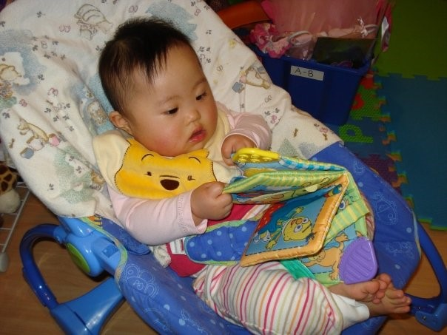
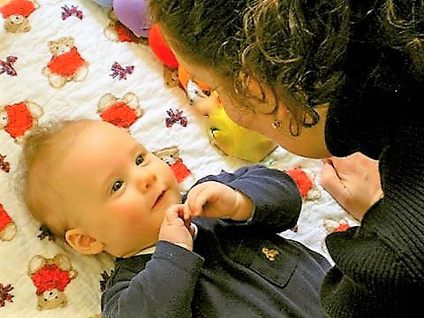
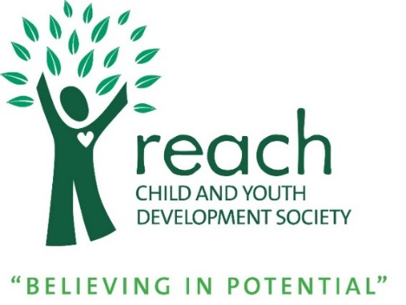
Infant Development Program
Program Handbook

5050 47th Avenue
Delta, BC V4K 0C8
604.946.6622
www.reachchild.org

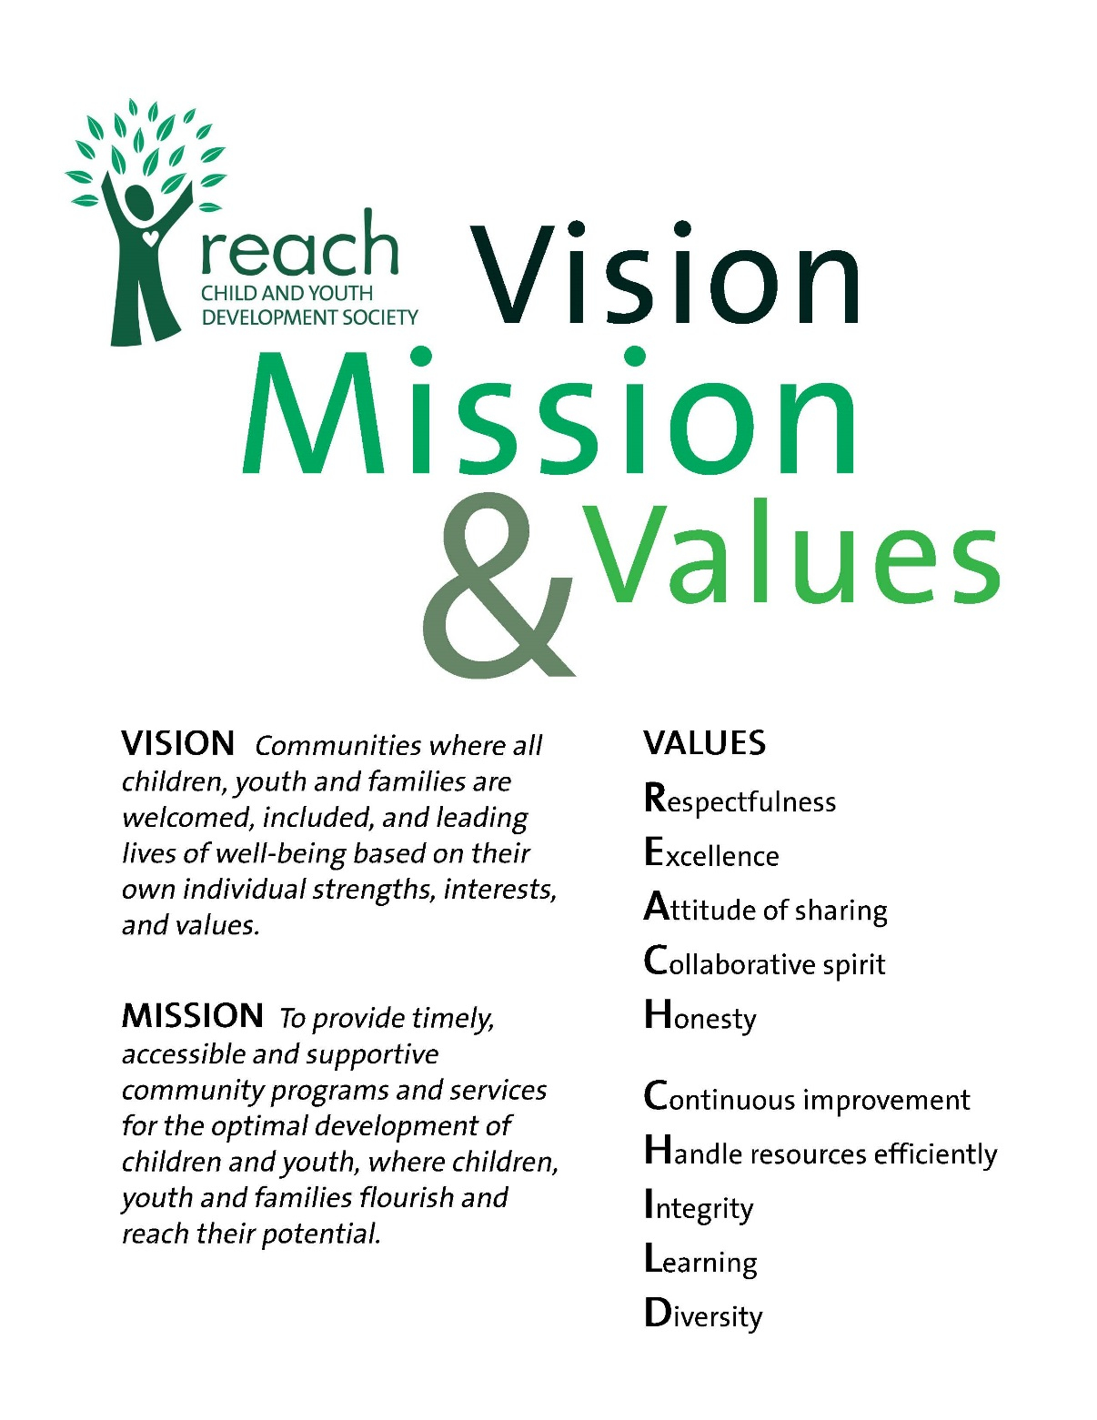

Guiding Principles

- Appreciating childhood as a unique and valuable stage of the human life cycle and basing our work with children and youth on the knowledge of children development.
- Appreciating and supporting the bond between the child or youth and family.
- Recognizing that children and youth are best understood and supported in the context of family, culture, community and society.
- Respecting the dignity, worth and uniqueness of each individual (child, youth, family member, and colleague).
- Helping children and youth achieve their full potential in the context of relationships that are based on trust, respect, and positive regard.
- That children are best nurtured by a family that knows, loves and honors them for who they are.
- That all children have the right to play and learn in an inclusive environment that meets the needs of children with and without disabilities.
- That relationships and friendships are essential to enrich our lives.
- That all individuals are entitled to the services and supports required to ensure their full participation in our society.
- That the involvement of families and support networks contributes to everyone’s safety and well-being.
- That services and supports must be delivered in a way that respects an individual’s diverse history, culture, race, religion and sexual orientation.
- That inclusive communities enrich the lives of all citizens.
Table of Contents
Page

What Is IDP? 1
Family Centered Practice 1
What is the consultant’s role? 1
What is the caregiver’s role? 2
How often will I see a Consultant? How long will they work with us? 2
What if someone is ill? 2
What training/education do IDP Consultants have? 3
Referral to the Infant Development Program 3
Group Opportunities 3
Play Group 3
Infant Songs and Rhymes 3
Infant Massage 4
Safe Work Practice 4

What Is IDP?

The Infant Development Program is here to help families in their parenting journey. IDP is a voluntary home visiting program that provides a range of family-centered services to families of children birth to age 3 who may be at risk for or have a developmental delay or who have a diagnosed disability. The program is funded by the Ministry of Children and Family Development and there is no cost to receive services.

IDP provides services that support your goals for your child and family, assisting you to:
- Have information about your child’s development. This includes gross motor, fine motor, communication, cognitive, social-emotional and self-help skills.
- Learn about and access community resources and IDP groups and workshops.
- Identify the changes you would like to see happen as a result of being a part of the IDP program.
- Develop strategies to encourage your child’s development within your family’s everyday routines and activities.

Family Centered Practice

Families know their children best and are the most important and constant factor in their child’s lives. In family centered practice, the needs of the family as a whole are honored. The family's involvement and participation is a recognized key factor in the achievement of successful outcomes.

What is the consultant’s role?

The IDP Consultant will visit with you and your child at your home, playgroup and/or other locations your child may attend (community programs, parks, day care, etc.). To help you achieve your goals, the IDP Consultant will also:
    - Help you learn about your child’s development through observing, commenting and providing you with information.
    - Provide developmental screening tools, including standardized assessments, to help monitor development as requested.
    - Support you in accessing community resources.
    - Advocate with you for additional resources, services, and support.
    - Help with referrals to and collaborate with other community professionals.
    - Loan you books, articles, toys and/or equipment as requested.

What is the caregiver’s role?

- Actively participate during visits with your child.
- Actively participate in the planning of what visits will look like.
- Identify developmental strategies and activities with your consultant that are fun and playful.
- Try strategies and activities in between visits.
- Give feedback and ask questions.
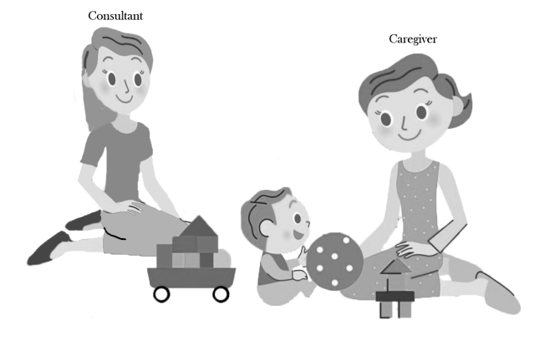

How often will I see a Consultant? How long will they work with us?

How often and for how long services are provided is based on the individual needs of your child and family.
Together we will talk about how often IDP will visit based on your child’s needs. We might see you regularly (once a month) or less frequently. We will make this decision with you.
IDP may work with you until your child is 3 years old but families are not always involved for that long. Together we will monitor how things are going with your child’s development and decide if IDP should continue to work with you. You can also choose to stop receiving services at any time.

What if someone is ill?

IDP consultants work with a variety of children, many of whom are medically fragile, thus we request that if we have a visit scheduled and you, your child or someone in your household is ill with a cold, flu or any other contagious illness that you notify us as soon as possible to reschedule the IDP visit.

What training/education do IDP Consultants have?

All the IDP Consultants have a degree in a field related to early childhood development and have worked with children with developmental support needs and their families. They have a thorough understanding of child development, strategies to support development and community resources.

Referral to the Infant Development Program

It is not required that a child have a diagnosis to access our services. Children are eligible for Reach IDP if they live in Delta, are newborn to age 3, have a diagnosed disability or may be at risk for or have a developmental delay. Referrals require permission from parents and are made by parents, physicians, public health nurses and other community professionals. Referral forms can be found on the Reach Child and Youth Development Society website at www.reachchild.org.
Each child and family presents a unique situation, the urgency of which is to be assessed in relation to others on the waitlist. The following considerations are reviewed when determining the provision of consultation services: transfer from another program, recent diagnosis, the degree of developmental delay, age of the child, family situation and other services being accessed.

Group Opportunities

Our Infant Development Program offers families the opportunity to participate in various group activities with their child. These include:

Play Group
The Infant Development Program Playgroup is for families who are currently referred to or receiving consulting services from the Infant Development Program. It is a child and family centered environment where development and learning is encouraged. Children learn through play experiences. The playgroup is facilitated by and Infant Development Program Consultant.

This playgroup is currently offered in our North Delta location:
North Delta
Wednesdays, 10:00 – 11:30
11415 84th Avenue
Delta, BC

Infant Songs and Rhymes
Infant songs and rhymes is a group experience for parents and their babies up to 12 months which focuses on the pleasure and power of using rhymes and songs together. Parents gain skills and confidence which can enable them to create positive family interactions during their children's crucial early years, and give their children healthy early experiences with language and communication.

This program is offered at different times in North and South Delta. The Infant Development Program will inform you of upcoming sessions.

Infant Massage
Infant massage is a five week program for parents and their babies from birth to pre-crawling. Infant massage encourages bonding and attachment, and has benefits of promoting interaction, stimulation, relief and relaxation. Aside from specific massaging strokes, parents will also gain confidence in learning how to read their baby’s behavioral states and unique cues.
This program is offered at different times in North and South Delta. The Infant Development Program will inform you of upcoming sessions.

Reach Child and Youth Development Society Infant Development Program
Safe Work Practice

Worksafe BC requires that employees wear shoes at all times. IDP Consultants are asked to have clean shoes that have not been worn outside or hard soled slippers available to wear during meetings inside a family’s home.

For more information about IDP contact:
Leora Shipley, Coordinator
Phone: 604-946-6622, ext. 303
Email: leoras@reachchild.org

