**Resources Available to Assist with Routine at Home**

**There are many resources attached. First, some reminders on supporting our children through these difficult times.**

Taking Care of Children in Alarming Times

[Gordon Neufeld](https://neufeldinstitute.org/author/dr-gordon-neufeld/)

I’d like to share a few thoughts on taking care of children in alarming times. These are not new ideas by any means, more like reminders for those who are familiar with the attachment-based developmental approach. I’ll try to keep it brief as alarm has a way of shortening our attention spans.

But first, some comments on the nature of the stress we are experiencing during this crisis. It is only natural that in times of stress, we seek togetherness. This is how we are wired. But in this case, togetherness – at least in the form of *‘being with’* – is what threatens us, thus creating a perfect emotional storm. No wonder we feel so rattled and unsettled. We are meant to come together in order to take care of each other and our loved ones. Now we are asked to keep our distance to keep each other safe. As imperative as it is in these times, it goes against the grain of our instincts and that of our children. I can’t imagine what it is like for the spouses of hospitalized partners right now.

Given the conflict between what we feel like doing and what we need to do, there are two possible paths to appropriate action. For those capable of mixed feelings, the inner conflict becomes immense but also foundational to good problem-solving. For those not capable of mixed feelings – which include most young children and a disproportionate amount of adults – they are badly in need of well-spelled-out *scripts\**. These scripts become the main challenge of parents – translating an alarming world into easy-to-follow scripts that each particular child is capable of executing.

We must try to avoid alarming them in order to move them to caution. Alarming children directly is counterproductive on many levels, not the least of which is that it evokes deep insecurity and strong alpha impulses, both of which interfere with being able to keep them safe. Non-alarming scripts should be our modus operandus. Remember, scripts need to be simple, positive and do-able. Do make sure you engage the child before you provide and model the script, otherwise it can backfire, producing resistance or counterwill instead. So collect your child’s eyes, smiles and nods before proceeding.

Remember also, that one of the most important places of safety for children is being in the presence of a strong caring adult with a good alpha presence. No matter how scared we are and how little we know about what is happening or going to happen, we are still our child’s answer – including their bubble of safety in an alarming world.

Remember as well, that children at play are insulated from the alarming world around them. Play is a sanctuary of safety. Play is also the original school, far more effective anything society could possibly invent. Rather than try to make the home a school, it would be much more important in these times to make the home a true playground where Nature can take care of all of us. In true play, the engagement is in the activity, not the outcome. Most screen play does not qualify.

One more word of caution. Thwarted togetherness is the fountainhead of our frustration, so don’t be surprised if you find more attacking energy lurking just under the surface of your interaction. My foul frustration has certainly caught me unawares, sometimes erupting at the most unexpected times. In the interests of taking care of our children, we need to find safe emotional playgrounds for our frustration. We also need to make regular play-dates with our sadness as this is probably the only way to keep truly civil in these times. If you are a painter, you will need to paint. If you are a writer, you will need to write. If you gravitate to music as an emotional playground, remember you will need it more than ever at this time. Neglecting to grieve the unfolding tragedy, including uncertainty and mortality, will only set the stage for more wounding. We owe it to our loved ones to remain soft and gentle during this time.

*Scripts – the following excerpt on scripting is from Dr. Neufeld’s book [*Hold On To Your Kids*](https://neufeldinstitute.org/resources/hold-on-to-your-kids-book/)*.*

*To script a child’s behavior is to provide the cues for what to do and how to do it ….  Successful scripting requires the adult to position himself as a cue-giver for the child. Again, we begin with the basics: we collect the child first in order to be able to work from within the relationship. It is very much like the mother goose with goslings; getting the offspring into line before bringing the behavior into line. Once a child is following us, we are free to take the lead. Of course, our ability to prescribe a child’s behavior will be only as good as the child’s attachment to us. It doesn’t have to be particularly deep or vulnerable, only strong enough to evoke the instincts to emulate and to imitate.*

*For successful directing, the cues for what to do and how to be must be given in ways the child can follow. It doesn’t work to give negative instructions because that does not actually tell the child what to do. In fact, for the immature and severely stuck, all that registers is often the action part of the command! The “don’t” is often deleted from awareness, leading to the opposite behavior of what was desired. Our focus must be diverted away from the behavior that causes trouble and focus on the actions that are desirable. Modeling the behavior you want the child to follow is even more effective. Like a director working with actors or a choreographer with dancers, the end result is created first in the adult’s mind.*

**Other Important Considerations:**

Our children may be feeling some anxiety, fear and sadness due to the isolation from their friends, extended family, their schools and the feelings they sense from the big people in their lives.

This can be a very traumatic time for all of us but it is our job to help our children through this. Strong and trusting relationships protect our children from trauma not worksheets of ABC’s and 123’s.

Strong family relationships are what is necessary right now for children to feel safe and loved. Feeling safe, loved, valued and respected helps:

* brain development
* eating, sleeping, learning and behaviours
* one to solve problems and resolve conflict
* one to build external healthy relationships

With schools being closed it is tempting to think that the focus should be giving our children academic worksheets and projects to ‘keep’ them up in their education. However, Social and Emotional Growth is one of the core pieces of our provincial mandate. This is where a family can excel in helping their children develop during this time. The other two areas in the core competencies include Communication and Creative and Critical Thinking, both of which we can also include in our day-to-day activities with our children. This is the perfect opportunity to help our children grow in all areas of brain development in a safe and engaging environment.

A daily routine filled with fun and a variety of activities can be very reassuring for children during this time. Numeracy and literacy are present in most of the everyday activities that children can do in a home routine.

The daily routine should include a variety of choices:

* active/physical – nature – get outside
* quiet – reading
* crafting
* down time
* hobbies – try something new
* games/cards with family members
* connecting with other family and friends in a safe manner – telephone, letters, computer – virtual visiting!
* hygiene routines
* meals – cooking
* screen time could include visiting other countries, museums, virtual rides – there are many options on the internet
* PLAY
* “I love you” rituals and “we do” activities

Throughout the day take some opportunities to build your relationship with your child. SLOW DOWN and listen to them. We have the most incredible opportunity right now to really look at our children and see who they are and learn from them!

Two wonderful activities to help build relationship are “I love you” rituals and “we do” activities.

**Love You Rituals** are the little things you do the same every day. Remember when your children were little and you may have had little songs or gestures that you did daily – maybe a tooth brushing song, lullaby or favorite book to read together. These are Love You Rituals and they are very reassuring for children because they are predictable, familiar and build trust and relationship. They change over time depending on the age and preferences for the child but please know how important they are to the child and to the relationship Here is a link to some more information about Love You Rituals: <https://www.youtube.com/watch?v=bl7b3TespAw>

**We Do Activities** These are special relationship building activities based on building relationship NOT the activity itself. For example, if your child likes to spin the wheels on cars or line toys up you join in with the activity by also spinning the wheels or lining up the toys. The focus here is on making safe eye contact and smiles of enjoyment doing a shared activity. This is not the time to say ‘a car goes vroom” or “toys are for playing with”. This relationship building exercise comes from Dr. Stanley Greenspan’s Floortime Model, you can learn more about it here: <http://www.autism-help.org/intervention-floor-time-dir2.htm>

Look for something that your child likes and try to join in, gain their trust and ‘play’ together. You can do this with all ages of children as it depends on what THEY like to do (from infant toddler toys all the way to gaming systems). Here is a link to some play ideas”: <http://www.atotalapproach.com/images/docs/Toy_list_2012.pdf>

There are many ideas on the internet for family relationship building activities. Here are a couple of good ones:

<https://hearttohearthomeschooling.com/100-relationship-building-for-families/>

<https://www.families-first.net/uploads/userfiles/files/FL_Youth_02.pdf>

**Resources**

|  |  |  |  |  |  |
| --- | --- | --- | --- | --- | --- |
| Resource  Name | | **Appropriate Age Range** | **Learning Outcomes Associated with Resource** | **Website** | **Comments** |
| All The Right Type | Multiple | | Keyboarding | <https://www.atrtonline.ca/index.html> |  |
| IXL | K-12 | | Numeracy / Math / reading | <https://ca.ixl.com/?partner=google&campaign=71592328&adGroup=2429438848&gclid=EAIaIQobChMImabOsOHD6AIVBMRkCh3SxQhIEAAYASAAEgJlgPD_BwE> |  |
| Great School | Grade 1-5 | | Reading phonetics  Reading comprehension  Numeracy | <https://www.greatschool.org/gk/worksheets/> |  |
| Playdough | 3-10 | | Art / science | <https://www.jillianharris.com/10-things-to-do-with-kids/> | Look for Leo and Annie’s Play dough |
| Get Ready Do Done | Multiple | | Executive functioning – task sequencing | Attached in this document |  |
| Be Your Own Pilot and Read the Room | Multiple | | Executive functioning – Situational awareness (the ability to read the room) | Attached in this document |  |
| Bird Backpack | Multiple | | Science and nature | Attached in this document |  |
| Make a creature | Multiple | | Critical Thinking | Attached in this document |  |
| Make your Menu | Multiple | | Critical Thinking | Attached in this document |  |
| Squeeze in Words | Multiple | | Critical Thinking | Attached in this document |  |
| Idiom Game | Multiple | | Communication | Attached in this document |  |
| Matching Comments | Multiple | | Communication | Attached in this document |  |
| Questions, Comments and Compliments | Multiple | | Communication | Attached in this document |  |
| Who Lives Here? | Multiple | | Science and Nature | Attached in this document |  |
| Using a Clock for Scheduling, Time Management and Transitions | Multiple | | Executive Functioning | Attached in this document |  |
| What Do You Say When? | Multiple | | Communication | Attached in this document |  |
| Dolphin Kids | Grades k-8 | | “POD” based method - Learning, lifeskills and resilience | <https://docs.google.com/spreadsheets/d/1Hz9LrhGLdAQvCHwASNOJ9eaynIYA3JwsGMWsaE6bUEk/edit#gid=0> |  |
| Sibling resources | Multiple | | Multiple | <https://lookaside.fbsbx.com/file/Sibshops%20Book%20List%20Update.xlsx?token=AWzmKGz53sevmDC2Lb3CQ3sk0G9uqCrvF_mhikoZyyD_nLRD6DbNIisVc9T4X-jXGMOiHiIlXeRfh9YxhsFXjjToo58D_gLgXLEHevXg-CIpuYS5SyHG6qHXDiY8BqHcm0Axf_te-AMs_vVnvjTib9z6bjQisrswaIf82N0GLxOPN6BZ4KeWQsASRHAvX_5D3GiBmIf8Ysjie0vo_HdcSuBP> |  |
| Twinkl | Multiple | | Multiple | <https://www.twinkl.com/offer>  Code **CVDTWINKLHELPS for 1 month free** |  |
| Scholastic | Multiple | | Multiple | <https://shop.scholastic.co.uk/homelearning?source=aw&awc=2957_1585355798_5aefcc8e19032281ba70cdae833f43fe> |  |
| Sparklebox | Multiple | | Primary ages | <https://www.sparklebox.co.uk> |  |
| Starfall | Multiple | | K-3 | <https://www.starfall.com/h/> |  |
| Timestables Rockstars | Multiple | | Times tables | <https://ttrockstars.com> |  |
| Sumdog | Multiple | | Math and Spelling | <https://pages.sumdog.com> |  |
| BBC | Multiple | | Multiple | <https://www.bbc.co.uk/teach> |  |
| PBS Kids |  | |  | <https://pbskids.org> |  |
| Indoor Games and Activity Ideas | Multiple | | Multiple | <https://drive.google.com/file/d/1U26PKLsQ-FpPrx3OUzDDkLqK27-fbDhG/view?_ke=eyJrbF9lbWFpbCI6ICJwYW1jQHJlYWNoY2hpbGQub3JnIiwgImtsX2NvbXBhbnlfaWQiOiAiTU1TYWJmIn0%3D> |  |
| ABC Mouse | Ages 2-8 | | Multiple | <https://www.abcmouse.com/abt/homepage?8a08850bc2=T1671361463.1584450456.0586> | More than 9,000 online activities for children aged 2 to 8 years old |
| ABC YA | Multiple | | Multiple | <https://www.abcya.com> |  |
| Boom Learning | Multiple | | Multiple | <https://wow.boomlearning.com> | Interactive Lessons |
| Brainpop | Multiple | | Multiple | <https://www.brainpop.com> |  |
| Dreamscape | Grades 2-8 | |  | <https://www.squigglepark.com/dreamscape/> | Reading Games |
| Funbrain | Grades Pre k - 8 | | Multiple | <https://www.funbrain.com> |  |
| Go Noodle | Multiple | | Physical Education / Movement | <https://www.gonoodle.com/blog/gonoodle-games-movement-app-for-kids/> |  |
| Highlight Kids | Multiple | | Multiple | <https://www.highlightskids.com> |  |
| Kids Discover | Ages 6-14 | | Reading / STEM | <https://www.kidsdiscover.com> |  |
| Learning A-Z | Multiple | | Literacy and Science | <https://www.learninga-z.com> |  |
| Nat geo for kids | Multiple | | Multiple | <https://kids.nationalgeographic.com> |  |
| Phonics Hero | Early Readers | | Reading | <https://www.phonicshero.com> |  |
| Cosmic Kids Yoga |  | |  |  |  |
| Storyline | Multiple | | Multiple | <https://www.storylineonline.net> |  |
| Switch Zoo | Multiple | | Science and Reading | https://switchzoo.com | Create Animal, biomes, habitats |
| Time Magazine for Kids | Grades K-6 | | Multiple | https://www.timeforkids.com | Great articles and virtual resources |
| Vooks |  | |  | <https://www.vooks.com/resources> |  |
| Wonderopolis | Multiple | | Science | <https://wonderopolis.org> |  |
| Audible Stories for kids | Multiple | | Reading | <https://stories.audible.com/discovery> | Free selection available |
| Museum Tours | Multiple | | Social Studies and Multiple | <https://artsandculture.google.com/project/street-view> |  |
| Everfi | K-12 | | Multiple | <https://platform.everfi.net/remote_learning> | Free virtual education hub for Canadians |
| Disney Zumba | Multiple | | PE | <https://insidethemagic.net/2020/03/disney-zumba-lp1/?utm_content=bufferc48d3&utm_medium=social&utm_source=facebook.com&utm_campaign=buffer> |  |
| Headspace | Multiple | | Social / Emotional | <https://www.headspace.com/meditation/kids> |  |
| ASL eBooks | Multiple | | Multiple | <https://docs.google.com/document/u/0/d/1rgAG1vqyU1RAlOZOXSvdyPk0Y4gPN51jOFTqLKN00hw/mobilebasic> | ASL |
| Convo  Vimeo ASL Stories | Multiple | | Multiple | <https://www.convorelay.com/dspvideos> | ASL |
| Wash your Lyrics | Multiple | | Multiple | <https://washyourlyrics.com/> | Makes hand washing routine to almost any song lyrics |
| Nasa Kids Club | Multiple | | Science | <https://www.nasa.gov/kidsclub/index.html> |  |
| Geoguesser | Multiple | | Social Studies | <https://www.geoguessr.com/> |  |
| Virtual Museums and Zoos | Multiple | | Multiple | Vancouver Art Gallery: <https://artsandculture.google.com/streetview/vancouver-art-gallery/nQG02JpLIcWvqQ?sv_lng=-123.1205209445115&sv_lat=49.28286606860153&sv_h=-10.627590987868281&sv_p=0&sv_pid=D2RuAqkVlnYQ6kMF0RwvRA&sv_z=0.9999999999999997>  Ontairo Art Gallery online collection:  <https://ago.ca/collection/browse>  Calgary Zoo live Panda Cam: <https://www.calgaryzoo.com/visit/animals/giant-pandas#species-tabs>  Sea Lions at OrcaLab:  <https://explore.org/livecams/orcas/orcalab-steller-sea-lion-haulout>  Vancouver Aquarium live animal cams (penguins, otters, jellyfish)  <https://www.vanaqua.org/visit/live-cams-penguin>  Farm Food 360: <https://www.farmfood360.ca/?utm_source=domain&utm_campaign=www.virtualfarmtours.ca&utm_medium=redirect>  Pacific museum of Earth: <https://pme.ubc.ca/visit/virtual-tour/>  Canadian Museum of History online exhibits:  <https://www.historymuseum.ca/exhibitions/online-exhibitions/>  Canadian Museum of Human Rights:  <https://humanrights.ca/stories/all-stories>  Arts and culture: <https://artsandculture.google.com/>  Discover Education: Virtual Field Trips:  <https://www.discoveryeducation.com/community/virtual-field-trips/> |  |
| Learn to Draw | Multiple | | Multiple | <https://www.youtube.com/user/ArtforKidsHub> |  |
| 30 Day Lego Challenge | Multiple | | Multiple | <https://www.freehomeschooldeals.com/free-printable-30-day-lego-challenge-instant-download/> | Print off 30-day Lego challenge and read each day’s challenge with your child. |
| Epicure Cooking with Kids | Multiple | | Multiple | <https://www.epicurious.com/expert-advice/the-best-you-tube-channels-for-kid-friendly-cooking-videos-article> |  |
| Make Your Own Musical Intrsuments | Multiple | | Multiple | <https://www.google.com/search?safe=off&sxsrf=ALeKk024fGfr9iiLatAStSEMx8--y90hFA%3A1584401026084&source=hp&ei=ggpwXsGzApfH-gTB2Jm4Aw&q=Make+your+own+musical+instruments&oq=Make+your+own+musical+instruments&gs_l=psy-ab.3..0l3j0i22i30l7.909.909> |  |

**Sample Daily Schedule**

Please note, this is a sample schedule and will need modifications for your child:

**Academic time**: an educational video or game may be a good idea – sorting, matching games (c

**Creative time**: together creating a sensory bin with sand or different coloured water, baking fun shaped cookies or simple nibbles, making music (who doesn’t want to be a rock star!), board games.

**Chore time:** putting laundry away, wiping down your tables, putting away toys

|  |  |  |
| --- | --- | --- |
| Time of Day | Activity | Comments |
| Wake up | Breakfast | Sleep in late if allowable |
| After breakfast | Hygiene routine | Use Get Ready Do Done for Hygiene Routine |
| After hygiene routine | Break | Offer selection of break choices |
| After break | Outdoor activity | See Outdoor Activity Ideas |
| After outdoor activity | Break / lunch |  |
| After break / lunch | Play based activity |  |
| After play based activity | Virtual Fieldtrip | See Virtual Fieldtrip Ideas |
| After virtual fieldtrip | Communication practice |  |
| After Communication practice | Snack and Break |  |
| After snack and break | Child guided play activity with adult |  |

**\*Then follow your usual regular late afternoon and evening routine**

**Attached Resources:**

**Implementing the Get Ready Do Done Routine**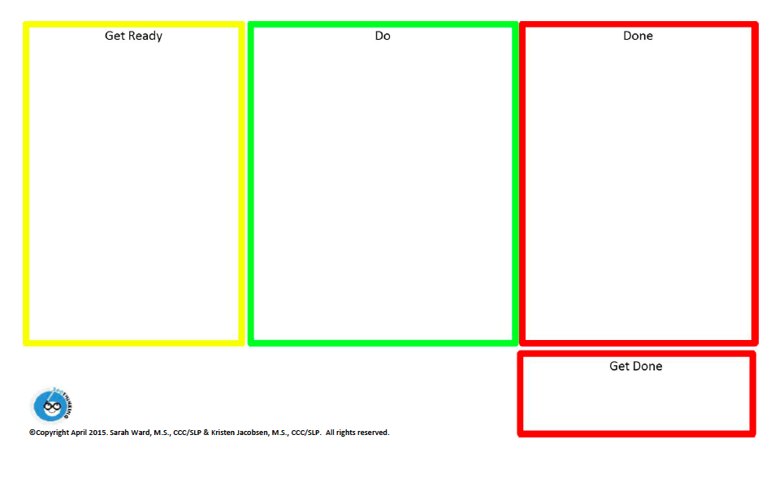Here is brief outline of how to utilize the   "Get Ready Do Done" template.

Laminate or use a page protector for the routine so it can be used with a dry erase pen.

|  |  |
| --- | --- |
| **Get Ready** | In this box you world include the supplies needed for the task. |
| **Do** | In this box you would list what is expected to be done in detail |
| **Done** | In this box you would include what the task looks like upon completion. If possible include of a photo of the completed task. If not feasible write a list of what a completed task looks like |
| **Get done** | In this box, you would put what has to be done with the work before you move on i.e. show teacher or put in backpack for homework. |

**Chunking a task like this is an effective executive functioning skills outline that helps children to build the sequencing pathways towards task completion.**

**Macintosh HD:Users:Heather:Desktop:School at home resources:GDDr lesson plan worksheet.pdfMacintosh HD:Users:Heather:Desktop:School at home resources:Be Your Own Pilot STOP and read the room.pdfMacintosh HD:Users:Heather:Desktop:School at home resources:Bird Backpack Activities.pdf**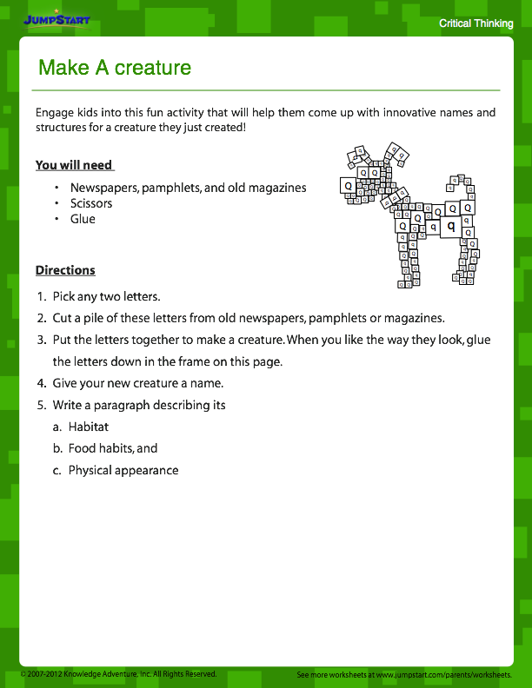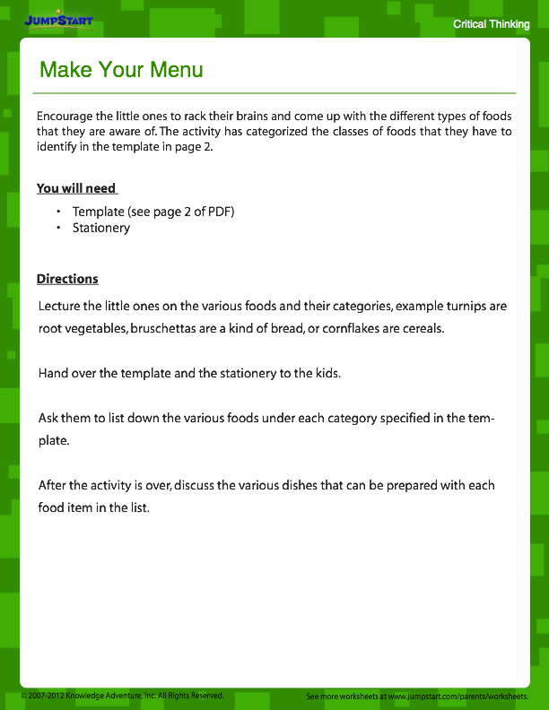

**Macintosh HD:Users:Heather:Desktop:School at home resources:Having Conversations 4:Matching Comments.pdfMacintosh HD:Users:Heather:Desktop:School at home resources:Having Conversations 4:What Do You Say When.pdf**

**Who Lives Here? Scavenger Hunt** Name: ______________________

Can you find these things in nature that tell us animals live here? Put a **C:\Users\ead\AppData\Local\Microsoft\Windows\Temporary Internet Files\Content.IE5\N7LO6852\MC900434713[1].wmf** next to what you see!

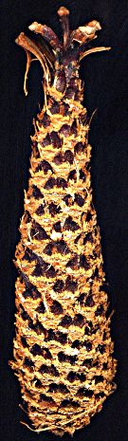



□

□

□

□

A feather

A chewed cone

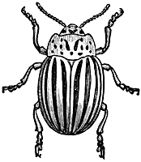

□

A bug



A leaf with holes

Tracks or marks made by an animal

A berry or fruit

□



**Using a Clock for Scheduling Time Management and Transitions**

**Materials:**

Clock

Multiple White Board Pens

**Instructions:**

Write the schedule hour by hour on the clock. Encourage the child to reference the clock to keep them on track, prepare for transition and mange their time. When they are unsure of how to proceed, redirect to the clock for a reference point rather than give the direction of the next task or transition.

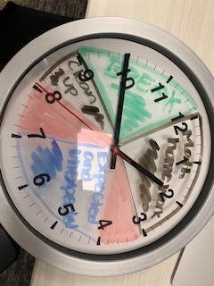

**Writing Prompts**

**Today I need:**

**(Circle the ones I need)**

|  |  |  |
| --- | --- | --- |
|  |  |  |
| **1 paragraph**  **2 paragraphs**  **3 paragraphs** | **I need lots of detail in my sentences. Including things like descriptive words.** |  |
| **1 person to edit when I am done** | **2 people to edit when I am done** | **Good copy typed and spell checked with name, date and title** |
| **A picture to go with my writing** | **The good copy to have colour** |  |

**Below, I can use this mind map to help with my paragraphs. I will put the main idea for the first paragraph in the middle bubble then the ideas to go with the paragraph in the outside bubbles.**

**Macintosh HD:Users:Heather:Desktop:School at home resources:Having Conversations 4:Questions, Comments, Compliments.pdf**

