The Pandemic Toolkit Parents Need

8 expert tips to help families stay regulated.

By Veronika Tait Ph.D.
Posted Apr 01, 2020

Our families will come out of this with greater personal strength and resilience as we
practice self-care, rely on others. Source: National Cancer Institute/Unsplash
As Coronavirus spreads throughout the globe, we are surrounded by tragedy and uncertainty. We find ourselves navigating a terrain that changes daily. Work interruptions. Family disruptions. Health concerns. It appears no one is immune to an increase in stress and anxiety as we traverse into the unknown.
On top of everything, parents are struggling to take on the new role of teacher as schools close or move to online coursework. We feel the current tension affecting our ability to adapt to a new normal. Where do we start? How do we help our kids when we need help ourselves?
Dr. Bruce Perry, child psychologist and trauma expert, has a helpful guide for parents looking for answers. His research on handling stress and staying regulated can inform us as we’re faced with challenges ahead. Self-regulation involves controlling our own behavior, emotions, and thoughts as we pursue long-term goals. This crucial skill is something parents can help develop in their children, especially during times of uncertainty and stress.
Stress does not have to be a bad thing if we respond in ways that increase our resilience. We can do our best to introduce stress to our children in predictable, moderate, and controllable ways.
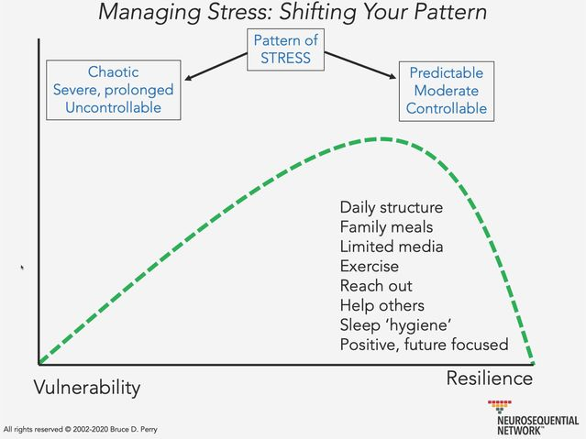

Dr. Bruce Perry's 8 Tips to help families stay regulated during times of stress and uncertainty.
Source: Bruce D. Perry, used with permission
Perry has proposed 8 tools for families to use during the Coronavirus pandemic:
1. Structure your day. As plans and expectations shift amid this global crisis, we can aim to continue routines with our children. Our children are more tolerant to stress when it is introduced in predictable ways, such as daily chores, bedtime routines, etc. It is when stress is unpredictable, extreme, and prolonged, that children become more vulnerable, rather than resilient.
2. Have family meals. Mealtime is a great way to preserve structure and routine while checking in with our children. If there are behavioral issues or family problems to discuss, we can ensure that our children feel safe and heard first. This will make them more receptive to our message. As Perry says, “We must regulate people before we can possibly persuade them with a cognitive argument or compel them with an emotional affect.” We can help our children regulate, then relate, then reason. Ensuring our meals are nutrient-dense will help our families handle an active stress response during this time.
3. Limit media. While navigating our way through this pandemic, many of us are experiencing a state of fear, and children are no exception. Just like the Coronavirus, emotions are very contagious, and children often sense when others are anxious or upset. In a state of fear, children rely more heavily on primitive parts of the brains. We should avoid media that is violent, which can further activate the stress response system. This leaves children unprepared to learn using more sophisticated parts of their brains. Technology can be an excellent tool to build connection with others while physically distant, but relying on media too heavily can replace time spent developing empathy, learning to ease another’s stress, and connecting emotionally.
4. Exercise. Now is the time to be creative and get bodies moving while practicing social distancing. As previously mentioned, when children are in a fearful state, they are in a heightened state of arousal, relying on lower-functioning brain regions. Perry states:
The only way to move from these super-high anxiety states, to calmer more cognitive states, is rhythm. Patterned, repetitive rhythmic activity: walking, running, dancing, singing, repetitive meditative breathing – you use brain stem-related somatosensory networks which make your brain accessible to relational (limbic brain) reward and cortical thinking.
5. Reach out. Connecting with others is one of our greatest tools. Perry tells us, “The most powerful buffer in times of stress and distress is our social connectedness; so let’s all remember to stay physically distant but emotionally close. Reach out and connect.” Handling such unprecedented circumstances is nearly impossible on our own. It is ok to reach out, seek help, and accept assistance. Taking care of our own needs is vital when it comes to meeting the needs of our children. An unregulated child cannot be regulated by an unregulated parent.
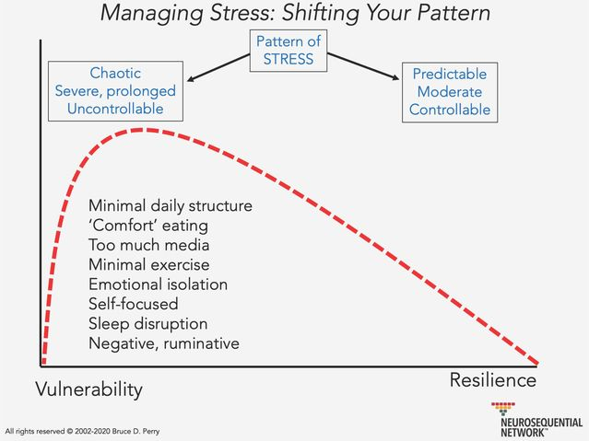
It is the moral obligation of those from a privileged background to look after the
distressed and marginalized. Source: Bruce D. Perry, used with permission
6. Help others. Many people who have experienced adversity in the past, are in a state of sensitization and vulnerability. They may have experienced poverty, racism, violence, marginalization, etc., increasing their risk for behaviors such as ‘comfort’ eating, emotional isolation, sleep disruptions, and so on. We can reach out to these individuals who are already prone to an overactive stress response. Perry emphasizes the moral obligation of those of us coming from a privileged background, who have learned resilience and coping strategies in predictable environments, to look after the distressed and marginalized. He states:
The real crisis of this current pandemic is not necessarily the next six months. It really is, What are we gonna [sic] do with the social and emotional toll that this is having on individuals and families, who will remain the most marginalized for the next six decades?
7. Practice good sleep hygiene. It is not unusual for us to be in a heightened state of alarm during this pandemic, feeling the need to always be ready for a threat. We may find ourselves growing physically and emotionally exhausted at a faster pace than normal. Sleeping a bit longer is normal while our bodies are in a heightened state of alertness. We can get more restful sleep if we exercise in the morning or afternoon, wind down with calming activities, and avoid late eating and screen watching.
8. Stay positive and future-focused. As mentioned previously, emotions are contagious. Perry informs us that, “The same way anxiety and panic is contagious, so is calm…Don’t underestimate your power to bring calm to others and don’t underestimate the impact of dysregulated people on you.” When we stay calm and regulated, those around us will feel less distressed. Everybody will be socially, emotionally, and physically healthier if we help each other model positive responses to stress. When we interact with things that deregulate us such as an abundance of negative news stories or relationships with anxious individuals, we can act to get regulated again by "filling our cup," using music, movement, social connections, journal writing, etc.
This is a trying and unprecedented time. Let us be gentle with ourselves and practice self-compassion. Let’s allow ourselves to grieve missed time with loved ones, travel plans, celebrations, and stability. We likely won’t be as productive as we would normally; we can preemptively decrease our workloads when possible before feelings of exhaustion overwhelm us.
Our families will come out of this with greater personal strength and resilience as we practice self-care, rely on others, and connect with the marginalized around us.

